## ✅ MVC2 Architecture – Pros and Cons

### ****Pros****

**a. Clear separation of concerns**

* Since we divide code into **Controller, Model, and View**, each has its own job.
* This makes the project **organized** and avoids mixing business logic with UI logic.

**b. Changes in one layer don’t break others**

* Example: If the database structure changes, only the **DAO/Model** layer is affected.
* The **Controller and View** remain the same → less chance of breaking the whole app.

**c. Easier maintenance and enhancement**

* Bugs can be **traced quickly** because responsibilities are clear.
* New features can be added in the respective layer without disturbing others.

**d. Parallel development improves productivity**

* One team can work on the **View (JSP/HTML/CSS)**.
* Another team can work on **Controller (Servlets/Spring Controller)**.
* Another team can work on **Model (Service + DAO)**.
* This saves time and speeds up delivery.

**e. Industry standard for medium & large projects**

* Almost all real-time Java web apps (Struts, Spring MVC, JSF, Spring Boot MVC) follow MVC2.
* It’s a **proven architecture** with lots of tools, documentation, and community support.

### ****Cons****

**a. More programmers required**

* Since layers are separated, **specialists** are needed:
  + UI developer for JSP/HTML/JS.
  + Java developer for Controller.
  + Database/Backend developer for DAO.
* So **small teams may struggle**.

**b. Requires knowledge of multiple technologies**

* Developers must learn **Servlets, JSP, JDBC, Services, DAOs, Frameworks**.
* A person working on a small project may find it **complex** compared to simple Model 1.

When we have MVC2 architecture to develop webapplications as layered applications, what is the need of webapplication frameworks in java?

**2. Problem with only MVC2 (without frameworks)**

If we directly implement MVC2 using Servlets and JSPs:

* We need to **write too much code manually** (URL mappings, request parsing, validation, etc.).
* We repeat the **same boilerplate code** in many servlets.
* It becomes **hard to manage** when project grows (hundreds of servlets, JSPs).
* No inbuilt support for common needs like security, form handling, database transactions.
* Testing and maintenance become difficult.

**3. What do frameworks add on top of MVC2?**

Frameworks like **Struts, Spring MVC, JSF** are built on top of MVC2.  
They provide **ready-made solutions** for the problems above.

Examples:

* They give a **front controller** (one servlet handles all requests, no need to write many servlets).
* They handle **URL mapping automatically** using configuration or annotations.
* They provide **form binding** (map HTML form values directly to Java objects).
* They support **validation, security, session handling** out of the box.
* They allow developers to **focus on business logic** instead of repeating plumbing code.
* They follow **industry best practices**, making applications more standard and maintainable.

**4. In simple words**

👉 **MVC2 is just a design pattern** (a way to organize code).  
👉 **Frameworks are tools** that implement MVC2 in a smarter way and give you many extra features.

So,

* If you use only MVC2 → you build everything yourself.
* If you use a framework → you save time, avoid mistakes, and get extra features for free.

## 1. Are MVC1, MVC2, Model1 design patterns or architectures?

👉 They are **architectures**, not design patterns.

* An **architecture** is like a **blueprint** for building the entire application.
* It tells **what big components exist** (like Controller, Model, View) and **how they interact**.
* Example: MVC2 architecture says “Keep request handling in Controller, business logic in Model, and UI in View. Don’t mix them.”

So, **Model1, MVC1, MVC2 are ways (architectures) to organize an application**.

## 2. What is the difference between Architecture and Design Pattern?

### Architecture:

* Big picture of the application.
* Talks about **layers/components** (Controller, Service, DAO, View, etc.) and **the flow of execution** (who calls whom).
* Example: MVC2 architecture tells how a user request travels → Controller → Model → View.

## Think of a Restaurant

### Architecture = the layout and roles

It’s the **overall setup**:

* **Front counter** (takes orders) → Controller
* **Kitchen** (cooks food) → Model
* **Menu board / bill** (shows info to customer) → View

This layout and who does what is the **architecture** (like **MVC2**).  
It answers: “What parts exist, and how do they talk?”

### Design patterns = common tricks used inside the setup

These are **small, proven ways** to handle repeat problems.

* **Front Controller**:  
  One main counter takes **all** orders, then sends them to the right chef.  
  (One entry point for all requests.)
* **Intercepting Filter**:  
  A quick check **before** the order goes to the kitchen (e.g., payment check, login check, logging).  
  (Pre-processing for every request.)
* **Business/Service Delegate**:  
  The counter doesn’t talk to every chef directly; it talks to **one service person** who knows which chef to call.  
  (Controller calls a simple service, not many complex parts.)
* **DAO (Data Access Object)**:  
  In the kitchen, **one person** handles the pantry and recipes. Cooks don’t dig in the store every time.  
  (Separate class for database work.)
* **DTO (Data/Transfer Object)**:  
  A **clean order slip** goes between counter and kitchen—only the needed info.  
  (Simple data carrier.)
* **View Helper**:  
  Someone **plates and decorates** the dish so it looks good on the table.  
  (Helpers/tags in the View to format data.)
* **Composite View**:  
  A **combo meal** is built from small parts—burger + fries + drink.  
  (Build a page from reusable pieces: header, footer, sidebar, content.)

## One tiny story (end-to-end)

1. Customer comes in → **Front Controller** receives every request.
2. A quick check runs → **Intercepting Filter** (auth, logging).
3. Counter asks a **Service Delegate** to handle the business step.
4. Service uses **DAO** to get/update data from the “pantry” (database).
5. Result comes back in a **DTO** (clean, simple data).
6. The **View** shows the result; **View Helpers** format dates/prices; **Composite View** assembles header + content + footer.

## Pocket rule

* **Architecture** = the **big setup** (parts + flow).
* **Design patterns** = the **small best practices** used **inside** that setup.

when we say **“architecture talks about layers/components”**, we mean the **big layers** in the application (like *Controller layer, Service layer, DAO layer, View layer*).

but here’s the important difference:

* **DAO (Data Access Object) as a layer/component in architecture**
  + in a typical layered architecture, we often say:
    - **Controller layer** → handles requests
    - **Service layer** → business logic
    - **DAO layer** → database access
    - **View layer** → UI
  + here, “DAO” is used to **name the layer** that deals with database operations.
  + so at the **architecture level**, DAO just means: “there is a data access layer.”
* **DAO as a design pattern**
  + when we **implement** that “data access layer,” we use the **DAO design pattern** to organize the code.
  + the pattern says: keep all DB code in one clean class (like StudentDAO), so other parts don’t directly touch database queries.

**🔑 simple way to see it**

* **Architecture**: high-level **layers** (Controller, Service, DAO, View).
* **Design pattern**: low-level **implementation style** used inside those layers (DAO pattern, Front Controller, View Helper, etc.).

so, the **DAO layer in architecture** is implemented using the **DAO design pattern**.  
that’s why the same word appears in both places, but the meaning depends on the level we’re talking about.

### 🔹 **Spring MVC Overview (In Simple Words)**

1. **What is Spring MVC?**  
   Spring MVC is a part of the Spring framework. It is used to build **web applications** (like websites or web services).
2. **Spring + Spring Boot = Auto Configuration**
   * When we use **Spring** and **Spring Boot** together, we get something called **Auto Configuration**.
   * Auto Configuration means most of the setup is **done automatically** by Spring Boot.
   * As developers, we don’t need to write a lot of configuration code manually. This saves time and reduces errors.
3. **How Spring MVC helps in Web Application Development**
   * Spring MVC lets you build web apps in two main ways:
     + Using **Servlets** (old style Java web programming).
     + Using **Spring Web MVC** (modern and easier way with Spring features).
   * You can choose the one that fits your project needs.
4. **Spring Version and Web MVC Support**
   * In **Spring 1.x**, we had:
     + **Spring MVC** (early version of web framework).
     + **Spring Web MVC** was used for basic web projects.
   * In **Spring 2.x**, we mainly used **Spring Web MVC** for web applications. It had better features and improvements.

## ✅ **Distributed Application vs Web Application (Simple & Clear Explanation)**

### 🔷 **1. What is a Distributed Application?**

* A **Distributed Application** is not fully located in one place.
* Different parts of the application run on **different systems or servers**.
* These parts **talk to each other using a network** (like the internet).

Mobile App (C) → API Gateway (PB) → Bank Server (B)

Mobile App = Client

API Gateway = Middle layer (PB)

Bank Server = Business Logic (Backend)

• **PB** actually **represents a real part** in architecture — the **middle layer**.

• That **middle layer** can be:

* A **Proxy** (like an API Gateway, Load Balancer)
* A **Broker** (like a Message Queue)
* A **Service layer** that handles routing or transformation

#### 📌 Example:

Mobile OS → GPay App → Banking Server

* The **OS** runs GPay (Client).
* GPay connects to the **Bank's Server (Business Logic)**.
* The flow is **distributed across different systems**.

#### 🛠 Technologies Used in Distributed Applications:

* ✅ **SOAP (Simple Object Access Protocol)** – XML-based communication, used in older systems
* ✅ **RESTful Services** – More modern, based on HTTP methods (GET, POST, etc.)

#### 🧠 Key Idea:

* Different components are **spread out** and **talk to each other through the internet**.
* The app is **not tightly connected** in one place.

### 🔷 **2. What is a Web Application?**

* A **Web Application** runs in a **web browser** (like Chrome or Firefox).
* It has a **frontend (Client)** and a **backend (Server)**.
* The **client directly communicates** with the backend using HTTP.

#### 🔁 Flow Diagram:

Client ↔ Backend

* The **Client (C)** sends requests.
* The **Backend (B)** responds directly — there’s **no middle layer like PB**.

✅ So, **C ≡ B** means **direct connection** between client and business logic .

#### 📌 Example:

Browser → Online Shopping Website

* The browser sends a request (like viewing a product).
* The server responds with data (like product info).

#### 🛠 Technologies Used:

* **UI/UX** – Designs how the app looks and feels.
* **i18n (Internationalization)** – Supports multiple languages and regions.
* **Spring Web MVC** – Java framework for building web apps using Model-View-Controller pattern.

## ✅ **Spring Web MVC Architecture (Simple Explanation)**

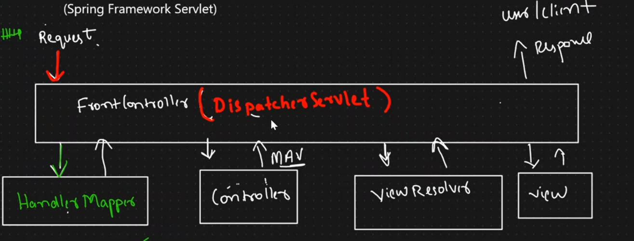

### 🔷 Spring Web MVC is built on two design patterns:

#### 1️⃣ **MVC Design Pattern**

* **MVC** stands for **Model - View - Controller**.
* It helps **separate the code** based on responsibilities:
  + **Model** = The data or logic (e.g., Student info, business rules).
  + **View** = What the user sees (e.g., HTML, JSP, UI screens).
  + **Controller** = Handles user requests and controls the flow (e.g., button click goes to a method).

✅ **Why MVC?**  
It makes the code **cleaner, easier to manage**, and **easy to update without affecting everything else**.

#### 2️⃣ **Front Controller Design Pattern**

* This means **one single controller** (entry point) handles **all the user requests**.
* In Spring, that is the **DispatcherServlet**.
* It acts like a **traffic controller** – it receives every request and decides where to send it.

## 🌟 Responsibilities of FrontController Flow

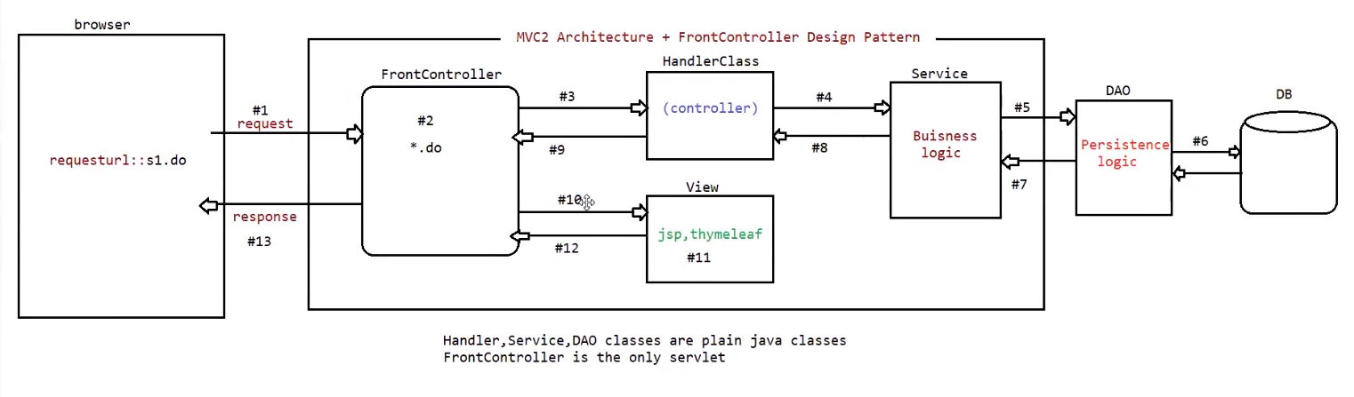

### 1. **Incoming Request**

* Every request from the user first comes to the **FrontController servlet**.
* Instead of having many servlets, we keep only one entry point.

### 2. **Pre-Processing**

* Before the request goes to the real logic, some **common checks** are done.
* Things like:
  + Logging → Who made the request, and when.
  + Security → Is the user logged in? Does the user have permission?
  + Cleaning the request → Making sure the data is safe.
* These are tasks that are needed for almost every request.

### 3. **Navigation Management**

* The FrontController decides **where the request should go**.
* Example: If the request is for /login, send it to the LoginHandler.
* This keeps all **routing rules** in one place, not spread everywhere.

### 4. **Handler / Service Execution**

* The chosen handler (or service class) now runs.
* It contains the **actual business logic**.
* If data from the database is needed, it may call the **DAO classes**.

### 5. **Data/Model Management**

* Handles the **data flow** between layers.
* Responsibilities:
  + Take input values (like form data) from the request.
  + Send them to the service or model layer.
  + Store the results (like a user object or product list) in request/session scope.
  + Make sure the data is ready for the view to display.

### 6. **Post-Processing**

* After the handler finishes, but before showing the view, some final work is done.
* Responsibilities:
  + Adjust or format the result data.
  + Add extra response details (headers, status codes, caching).
  + Clean up temporary objects.

### 7. **View Management**

* Now the FrontController decides **which page (view) to show**.
* Could be a JSP, HTML, or template page.
* Example: If everything is fine → success.jsp, otherwise → error.jsp.
* Keeps the **UI separate from the business logic**.

### 8. **Response Back to User**

* The chosen view is shown to the user.
* It can be an HTML page, JSON, or any other response.
* This completes the request-response cycle.